1. Create a github account if you do not have already.

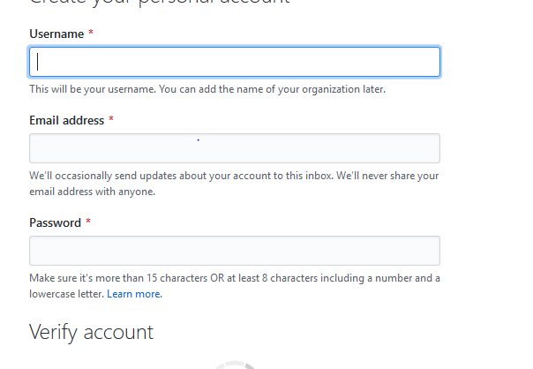

1. Login on into github account.

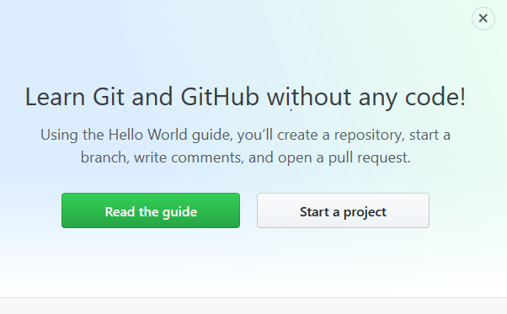

1. Create new public repository ‘freshersbatch’.

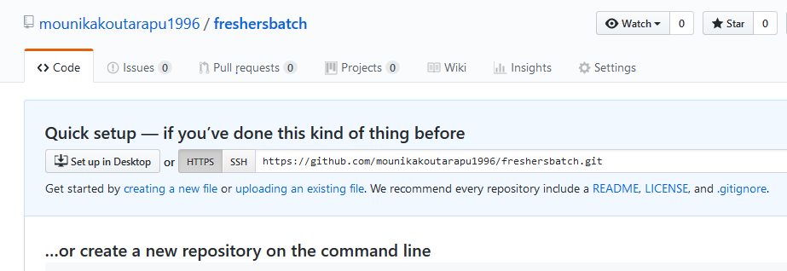

1. Commit & push any sample file to this repository under ‘Assignments’ directory.